MT Gulf Star 1
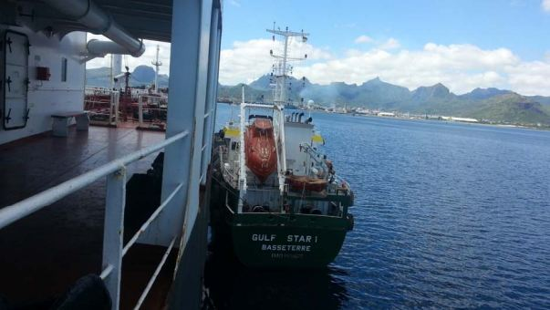

IMO: 9606077
MMSI: 341558000
Flag: St Kitts Nevis [KN]
Vessel Type: Oil/Chemical Tanker
Gross Tonnage: 1220
Deadweight: 1692 t
Length Overall x Breadth Extreme: 69.8m × 10.45m
Year Built: 2011

