**SIR SEEWOOSAGUR**

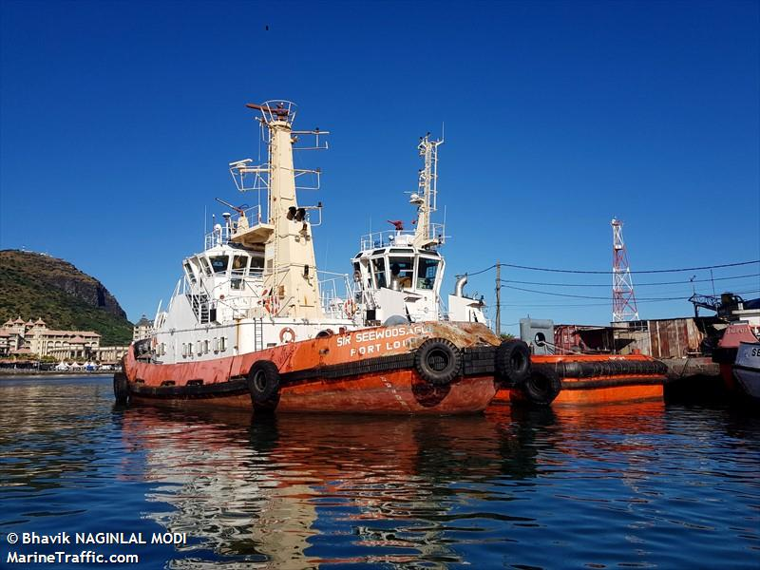

IMO: **8608432**

Call Sign: **-**

Flag: **-**

AIS Vessel Type: **Tug**

Gross Tonnage: **254**

Deadweight: **174 t**

Length Overall x Breadth Extreme: **29.25m × 9m**

Year Built: **1987**

Status: **Active**