**MAHE DE LABOURDONNAIS**

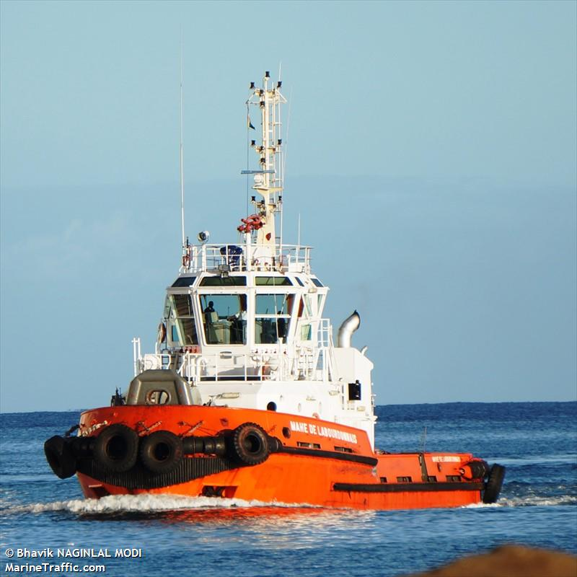

**IMO:** 9209441

**MMSI:** 645166000

**Call Sign:** 3BLS

**Flag:** Mauritius [MU]

**AIS Vessel Type:** Tug

**Gross Tonnage:** 275

**Deadweight:** 160 t

**Length Overall x Breadth Extreme:** 26m × 9.3m

**Year Built:** 2001

**Status:** Active