**DOMBEYA**

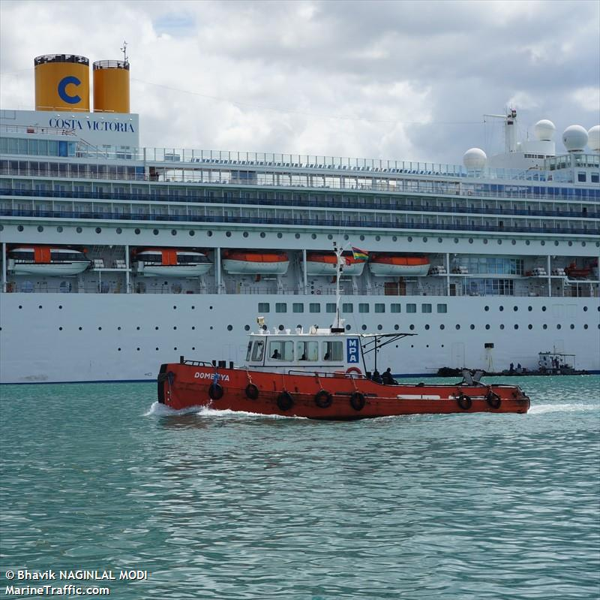

**IMO:** 9157882

**Call Sign: -**

**Flag: -**

**AIS Vessel Type:** Tug

**Gross Tonnage:** 41

**Deadweight: -**

**Length Overall x Breadth Extreme:** 16.89m × 5.29m

**Year Built:** 1999

**Status:** Active